|  |  |  |
| --- | --- | --- |
| http://profile.ak.fbcdn.net/hprofile-ak-ash4/373604_140473629361791_798225372_n.jpg  **Faculty of Science**  **Math. Dept.** | **Bank of Questions**  **Faculty of computer and Informations**  **Information Systems Program**  **Social Information Systems IS451** | **Assiut University** |

**Mark T or F for each true of false sentence, respectively.**

1. The graph data structure can be used to solve complex problems. [**T**]
2. Behind each complex system there is a network, that defines the interactions between the component. [**T**]
3. Assume that, the matrix E represents the adjacency matrix for a graph, the matrix E x E has no information. [**F**]
4. The bipartite graph can be represented as the complete network. [**F**]
5. The social network is a graph data structure, where the node represents person and the edge represents link. [**T**]
6. The facebook’s graph of people proofs that the six-degree separation theory is wrong. [**F**]
7. To proof the six-degree separation theory, we must estimate the shortest path between each two nodes. [**F**]
8. The oldest network is the metabolic network. [**T**]
9. The largest network containing nodes is the social network sites. [**F**]
10. In social networks, we can predict the link between the people. [**T**]
11. If you want to understand the spread of diseases, you need to figure out who will be in contact with whom. [**T**]
12. If you want to understand the structure of the Web, you have to analyze the ‘links’. [**T**]
13. The random graph generator can represent the real-world networks. [**F**]
14. Assume that we have next graph, the cluster coefficient for red node is 0.9. [**F**]

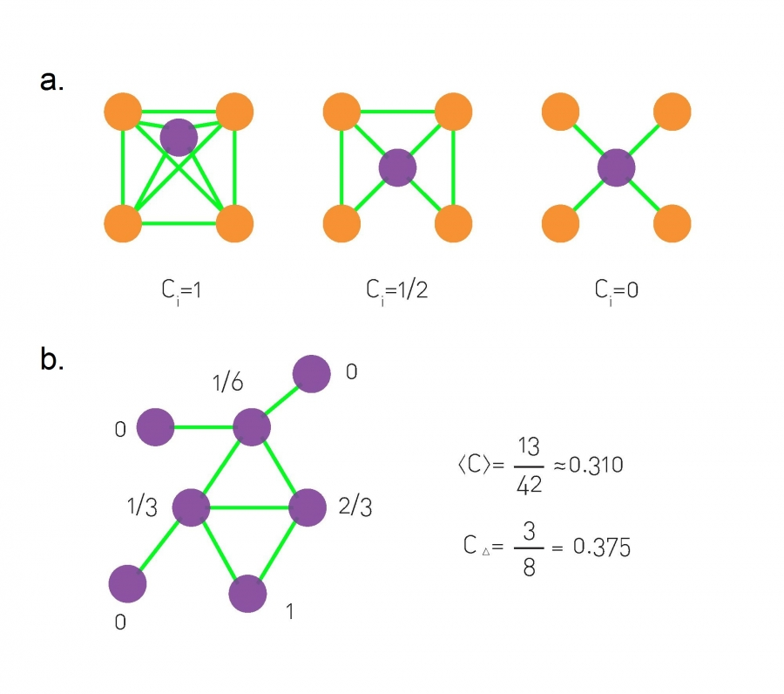

1. The concept of cluster coefficient comes from the analysis social networks. [**T**]
2. Preferential Attachment model can represent the real network. [**T**]
3. A node with high value of cluster coefficient means that the neighbors of this node have many shared links. [**T**]
4. We can see the concept of homophily in birds. [**T**]
5. The Granovetter’s concept says that the people knows about the jobs from their close friends. [**F**]
6. Onnela’s experiment proofed the Granovetter’s concept in real-world network. [**T**]
7. If two nodes have small value for the overlap coefficient, this that the link between these nodes is weak tie. [**T**]
8. Assume, we have the next graph, the overlap coefficient for red nodes is 1. [**F**]

1. If someone becomes obese, then his/her friend can be obese. [**T**]
2. The enemy of my enemy is my friend, this is a balance network. [**T**]
3. The enemy of my enemy is my enemy, this is a balance network. [**F**]
4. This balance networks are changed a lot with time. [**T**]
5. the Barabási-Albert model is a model that can generate random graphs. [**T**] in bank 2021 and , [**F**] in Final Review meeting
6. The richer becomes richer is the idea of the Barabási-Albert model. [**T**]
7. Barabási-Albert model, we the node is selected randomly, this means that all nodes have the same probability. [**F**]
8. Zachary's Karate Club dataset used in community detection algorithms, because this dataset contains small number of nodes. [**F**]
9. Clique Finder is one the best methods to find community in social networks. [**T**]
10. Two *k*-cliques are considered adjacent if they share *k* nodes [**F**]
11. Assume we have next graph. The green nodes represent the complete clique. [**T**]  
     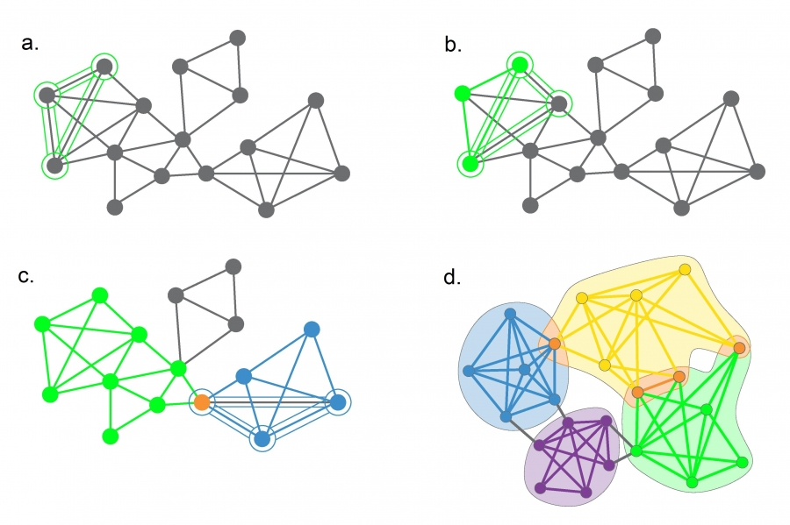
12. The maximum modularity hypothesis can measure the quality of community detection methods. [**T**]
13. The agglomerative hierarchical clustering is one of easiest method to find community in social network graph. [**T**]
14. The Ravasz Algorithm uses link betweenness measurement to find community detections. [**F**]
15. Affiliation Networks contains two types of nodes: person and Focal points of social interaction. [**T**]
16. We can use Affiliation networks in analyzing the spread of coronavirus. [**T**]
17. We cannot predict how the social network is formulated during large number of years. [**T**]
18. Ego network contains the persons and their behaviors. [**T**]
19. The fake news can be diffused into the social network. [**T**]
20. We can know the importance of the graph node from its degree. [**F**]
21. The next graph is called membership closure. [**T**]  
     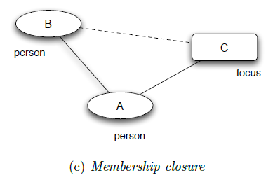
22. The next network is a balanced network. [**F**]

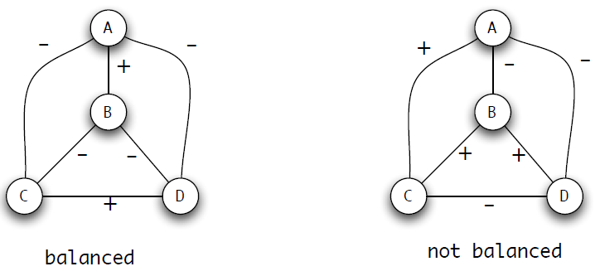

+

1. The student friendship in the first year in the university is a random network. [**F**]
2. For Erdős-Rényi network, the node degree distribution is only Poisson distribution. [**F**]
3. Social network can be used to predict the criminals. [**T**]
4. Network science is can be used in biology. [**T**]
5. Real Networks are supercritical. [**T**]
6. The critical point separates the regime where there is not yet a giant component (<k> > 1). [**F**]

**Assume we have the next graph and the adjacency matrix.**

**b**

**e**

**g**

**a**

**c**

**f**

**d**

**a b c d e f g**

**a I II**

**b**

**c III IV**

**d**

**e V**

**f**

**g**

**h**

51- What is the value of I

1. 0 b) 1 c) 2

52- What is the value of II

1. 0 b) 1 c) 2

53- What is the value of III

1. 0 b) 1 c) 2

54- What is the value of IV

1. 0 b) 1 c) 2

55- What is the value of V

1. 0 b) 1 c) 2

**Assume we have the next graph and the adjacency matrix.**

**b**

**e**

**g**

**a**

**c**

**f**

**d**

56- What is the degree of the node e

1. 2 b) 3 c) 4

57- What is the degree of the node b

1. 2 b) 3 c) 4

58- What is the degree of the node c

1. 2 b) 3 c) 4

59- What is the degree of the node f

1. 2 b) 3 c) 4

60- What is the degree of the node g

1. 2 b) 3 c) 4

**Assume we have the next graph:**

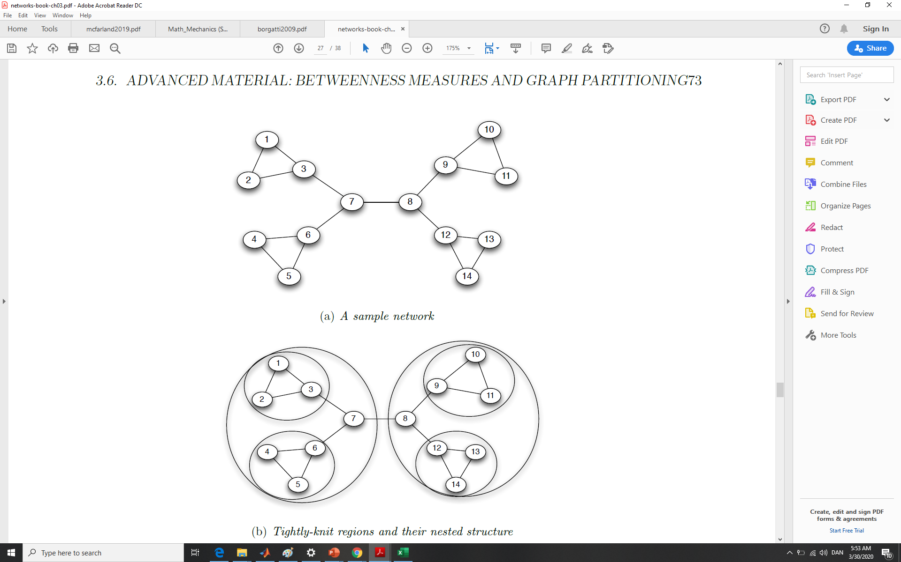

61- What is the value of link betweenness for the node 7 and 8?

1. 49 b) 33 c) 12

62- What is the value of link betweenness for the node 6 and 7?

1. 49 b) 33 c) 12

63- What is the value of link betweenness for the node 4 and 6?

1. 49 b) 33 c) 12

64- Which algorithm uses the link (betweenees)?

1. Girvan-Newman Algorithm
2. hierarchical clustering
3. Clique finder

65- In graph partitioning method, the first removed link is ….

1. 7-8 b) 6-7 c) 1-2

**Assume we have the next graph:**

**b**

**e**

**g**

**a**

**c**

**f**

**d**

66- The edge between c and d is called

1. link b) bridge c) tie

67- The edge between a and g is called

1. link b) bridge c) tie

68- How many are community in this graph?

1. 2 b) 3 c) 4

69- The relation between c and d is

1. normal b) strong c) weak

70- If d has strong relation with e and b, then e and b can has …..

1. a strong relation. b) a weak relation. c) a strong or weak relation.